Student’s name | …………………………………………………….…… | Grade | 5
Subject | Computer | Week No. | 4
Lesson Title | Wireless Communication | Unit
Worksheet No. ( 4 ) (Answer)

Instruction: Match the following

 | Router
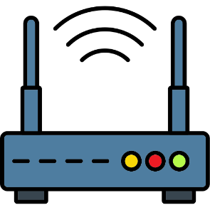 | Bluetooth
 | NFC
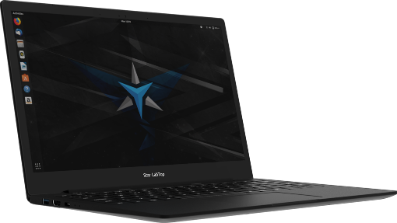 | Laptop

Good Luck

